Pipestone School
Positive School Environment Plan
2018-2019
Wetaskiwin Regional Public Schools

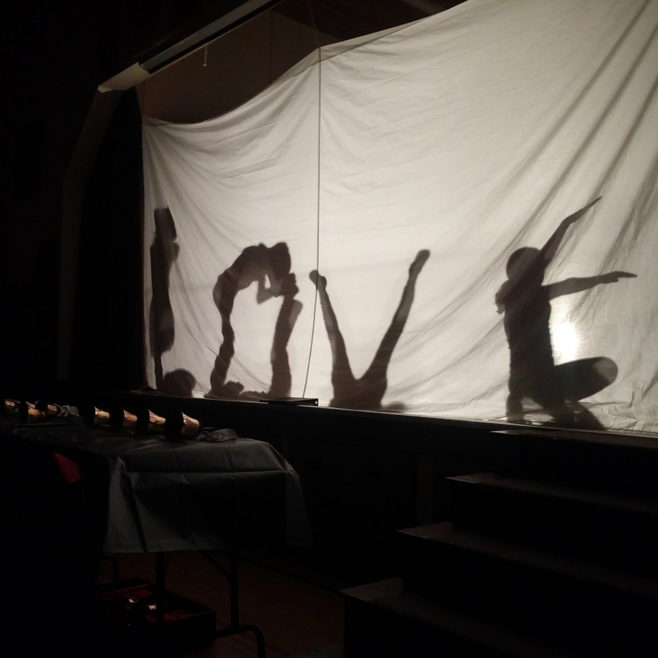

www.wrps.ab.ca
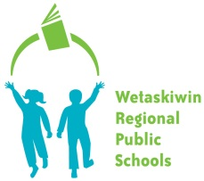 | Wetaskiwin Regional Public Schools  Positive School Environment and Healthy Relationships

WRPS Mission Statement:
“Wetaskiwin Regional Public School delivers quality education in a welcoming environment that is safe and caring. ”

Pipestone School Mission / Vision Statement
At Pipestone School we strive to provide each student with a safe, supportive learning environment where the school community creates the conditions for high student achievement.

What is a Positive School Environment?
A plan that meets Alberta Education (Education Act Code of Conduct), Wetaskiwin Regional (WRPS Student Code of Conduct; Discipline; Attendance; Assessment) and Pipestone School (Expectations For Student Behavior) mandates.

A plan that focuses and helping students feel that they belong at our school!

Pipestone School’s positive school environment supports our student’s growth with a community of caring peers and adults, led by staff members who find ways to help each student grow academically, socially and emotionally.

Pipestone School’s positive school environment has evidence based, effective behavior supports and procedures that focus on “catching kids being good”.

Building and maintaining a Positive School Environment is a Collaborative Process: Roles and Responsibilities

School Wide Positive School Environment: A Collaborative Process
Roles | Responsibilities
School Administrator | - Through collaboration with the school community holds leadership responsibility for providing an emotionally safe environment where students have a sense of Belonging.  - Articulates a clear philosophy regarding student code of conduct and discipline in the school  - Brings stakeholders together for visioning, planning and evaluating progress;  - Manages financial and material resources required to implement programming;  - Evaluates and reports outcomes to parent community and jurisdiction.
Guidance Counsellors and Family School Liaisons (FSLs) | - Collaborate with administrators and school teams in helping to explore and locate research based positive school environment programming that suits the unique school community;  - By exploring and identifying needs, gaps and strengths in the school environment;  - By administering and interpreting needs assessments and school culture surveys;  - consultation/collaboration support to LSTeam and teachers;  - liaising with community partners and organizations;  - Helping to activate student and parent voice in the assessment, implementation and evaluation stages of Positive School Environment programming.
Learning Support Teachers (LSTs) | - Work collaboratively to develop, document, implement and monitor interventions for students identified with academic/emotional/behavioral needs in Tier 2 and 3.  - Consultation/collaboration support for students with complex needs  - Liaise with school division student support personnel
Classroom Teachers | - Collaborate with administrators and school teams in implementation and evaluation of Positive School Environment programming.  - Ensure a positive classroom environment where students feel emotionally safe, respected and have a sense of belonging.  - Identify to the Learning Support Team those students who are not successful with tier one interventions alone.
Wellness Leaders | - Shares knowledge, expertise, skills and linkages to Comprehensive School Health and Health curriculum relating to students’ social/emotional/developmental needs, Healthy Relationships and Career Explorations.
Education Assistants | - Support and reinforce school wide and classroom expectations;  - Support individual students according to their Individualized program Plan (IPP).
Parents | - Provide insights into the social/emotional/developmental needs of the student body  - Collaborate with school staff to achieve a Positive School environment
Director of Support Services | - Through collaboration with school administration, staff and parents, holds leadership responsibility for ensuring emotionally safe environments where students have a sense of belonging.  - Brings stakeholders together for visioning, planning and evaluating progress;  - Reports outcomes to jurisdiction and province.

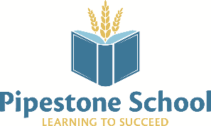

Supporting Kindergarten to Grade 6 Students at Pipestone School
Classroom Teacher  * Universal supports/class-wide interventions | - Differentiated Instruction  - Research-Based Reading practices and instruction (Adrienne Gear)  - Language Arts Traits for reading and Writing  - Implementation of High Yield Strategies  - Assessment For and Of Learning  - Classroom-wide screening  - Data collection & analysis  - Individualized, targeted intervention  - Guided Reading  - On-going, regular communication and reporting to parents  - Involvement of parents in their child’s education  - Fostering positive attitudes toward inclusion  - On-going professional development based on her/his Professional Growth Plan and alignment with School Plans  - Enhancing student engagement and learning  - Collaboration with colleagues
Learning Support Teacher  *Universal supports/class-wide interventions  * Targeted supports | - Level B Assessment and analysis– WIAT  - Coordination of and analysis of school-wide testing – DRA, CAT4  - Coordination, data gathering & implementation of school-wide guided reading program  - Coordination, implementation, and staff development of research-based reading comprehension program (Adrienne Gear)  - Implementing targeted assessments – i. e. specific math skills  - Gathering resources  - TA programming and support  - Team teaching  - Teacher coaching & collaboration  - In-class student support  - Coordination of service providers  - Coordination of and leading parent meetings  - Small group programming  - Data collection and analysis  - Behaviour support – student & teacher  - In-class observations of students for programming purposes  - School based coordination of assistive technology  - Fostering positive attitudes toward inclusion  - On-going professional development based on her/his Professional Growth Plan and alignment with School Plans  - Enhancing student engagement and learning  - Collaboration with colleagues, actively engaging in division based LST meetings & protocol  - Involvement of parents in their child’s education
Education Assistant  * Targeted supports | Implement the following programming provided for by LST & Classroom Teacher  - Speech and language development  - Implementing assistive technology with students  - Life-skills intervention  - Small group Guided Reading  - Intense Grade 1 Readiness Group addressing targeted, specific needs – OT, letter recognition & sounds, general classroom skills  - Intensive, short term pull-out for students needing specific skill development at certain points during the year  - Behaviour support and intervention  - Scribing & reading for students
Learning Support Team (Student, Parent/Guardian, Teacher, Education Assistant, Principal, Learning Support Teacher, Family School Liaison)  *Supporting all students & their families | - Coordinated, regularly scheduled team meetings  - Team approach  - Wrap-around intervention of teacher-identified student needs  - Communication between all stake-holders  - Involvement of parents in their child’s education  - Coordination of community services for students and families  - FSL is integral part of team and is a resource for students and families  - Foster positive school culture and safe and caring environment

School Behavior Support Philosophy:

Assess our needs. Set It! Teach it! Reward It!

- Pipestone School sets high expectations for the teaching and learning of healthy relationship skills for each student.
- We embed our teaching of healthy relationship skills in all aspects of school activities.
- We find fun and engaging ways to teach, reinforce and recognize healthy relationships.
- We teach kids to be their best, catch them being their best BUT make sure that there is a clearly stated behavior support process that is supported by firm, fair responses when student make inappropriate choices. Inappropriate choices become teachable moments that support healthy development for the child and their family.

Expected Outcomes in our Positive School Environment

- All students attending Pipestone Elementary will feel safe, cared for, welcome and comfortable, and engaged within the school;
- Students have positive and healthy relationships in our school;
- Students’ academic and emotional needs are understood and appropriately supported;
- Students have a sense of belonging at the school because they care about the school, our atmosphere, and our people.

Rational for targeting these outcomes: Teaching and learning toward these outcomes must be integrated into the daily lessons and routines of all staff members taking advantage of all “teachable moments”.

Outcome #1 – Research and practical knowledge are clear – students accomplish more when they feel safe, cared for, welcome and comfortable, and engaged! Pipestone Elementary School has skilled and enthusiastic supporters of student wellness who have established a tradition of focused devotion to the needs of our students. This dedication is reflected throughout the school building by all staff.

Outcome #2 – We know that students will encounter conflict and confrontation in their school lives. This outcome is supported by a variety of resources and strategies so that students, through positive, repeated situations, learn to recognize and appreciate everyone, develop empathy and skills of friendship. An important component is helping children understand conflict as a natural part of life and learning skills to deal with natural conflict. We strive to help our students to develop resiliency in the face of conflict based on building positive and healthy relationships.

Outcome #3 – This outcome is based on our belief that it takes a team or community to support a child and that the team works together to share information that best supports the growth of each child. Pipestone Elementary School ensures that staff members are kept abreast of concerns and developments that may impact our school and its students so that academic and emotional needs are understood and appropriately supported . The school’s Guidance and Counseling/Learning Support Team is comprised of the principal, the learning support teacher, the family school liaison worker, and all staff members, depending on the issue under discussion.

Outcome #4 - This outcome is part of our plan because of the belief that sense of belonging at the school is integral to successful schooling for our students. This outcome uses multiple sources of information including results, analysis and follow up sessions from the Ourschool Surveys. This outcome continues to build on past practices of recognizing the academic, behavioral, and athletic/ physical accomplishments of students on a regular basis (weekly, monthly, yearly) through announcements, classroom celebrations, school wide assemblies, and Gotcha rewards.
Year-end awards will continue to occur. Academic and character education awards are given out at the end of each school year. These are done in each classroom allowing for a more intimate setting for families and students. These in-class awards are followed by a school community lunch bar-be-que.

Ensuring a Positive School Environment: Action Plan

OUTCOME #1 & 2
Outcome | Target Group | Strategies | Who will Take the Lead? | Timelines | Evaluation
All students attending Pipestone Elementary will feel safe, cared for, welcome and comfortable, and engaged within the school;  Students have positive and healthy relationships in their school; | All students | Activities that give students chances to show they like school (classroom, gymnasium, outdoor recess play, clubs and teams, etc). | Principal | All year including regular assemblies | Conversations with students, staff, and parents; review of OurSchool and Accountability Pillar Data; review of discipline notes; weekly Learning Support Team meetings
 |  | Character Education/Competencies lessons embedded in all school situations; Gotcha lessons and rewards | All Staff | All year including weekly health lessons and weekly and monthly rewards
 |  | Positive, solution-based approach to behavior support; maximizing the “teachable moments” | All staff, including  Mental Health Capacity Building (MHCB) project leader | All year

OUTCOME #3
Outcome | Target Group | Strategies | Who will Take the Lead? | Timelines | Evaluation
Students’ academic and emotional needs are understood and appropriately supported. | All students | Targeted LST supports in all classrooms; Collaborative Response Model meetings; JEPD and PLCs | LSTeacher and Principal | Every second or third month | Conversations with students, staff, and parents; review of OurSchool and Accountability Pillar Data; FSLW input
 |  | Strategic Education Assistant supports where possible
 |  | Targeted FSLW interventions by student, parent and teacher request as required which include focus on resiliency. | FSL and MHCB worker | All year

OUTCOME #4
Outcome | Target Group | Strategies | Who will Take the Lead? | Timelines | Evaluation
Students have a sense of belonging at the school because they care about the school, our atmosphere, and our people | All students | Grade Five/Six Leadership and role modelling (eg. PE buddies with kindergarten; club leaders; recess helpers) | Principal, Grade five and six teacher(s) | All year | Conversations with students, staff, and parents; review of Our School and Accountability Pillar Data
 |  | Character Education/Competencies embedded in all school situations | All staff | All year
 |  | Ensuring students have play equipment, learning materials, and library resources that are in good repair, appealing, and appropriate to student needs | Principal with input from all staff members; MHCB worker | Continual awareness and review

School Priority, Targets and Measures

GOTCHAS - More frequent rewarding of specific, defined behavior targets at monthly assemblies, on morning announcements, display or shared with parents, weekly draws for a small number of students to have a quick and easy reward from a list of rewards created at the start of the year (eg. hot chocolate, extra recess, 5 min of gym time).
This will be reviewed as regular item on teaching staff or ALL staff meeting agendas or by email with staff to get input on the skill or behavior demonstrated results by students AND to get input on subsequent behavior skills that will be targeted. Two times per year student input will be sought as to which behavior skills are most important to make our school a better place.
All staff and sometimes students will hand out Gotchas
Teaching to the skill - Principal or another staff member create mini-lessons
Measure: Check in with staff at two or three times in the year including May 17th non-instructional day for year long review; Survey or focus group input from students

TIER 1 – Universal, TIER 2 Targeted or TIER 3 Specialized Interventions
Tier 1 – are the things we do for all of our students all of the time. Tier 1 focuses on school wide strategies and resources with high expectations for best learning and behavior. Assess our needs. Set It! Teach It! Reward it!

When do we move to Tier 2 Targeted Interventions?
When Tier 1 School Wide Positive School Environment supports have been insufficient to support a student’s social/emotional needs and/or success, moving to Tier 2 interventions is indicated

How does a student access Tier 2 intervention?
Typically the referring teacher will complete a quick checklist to communicate strengths, issue, concerns, and reason for referral.
Checklists to gather good information about the students’ strengths, interests and needs as well as parents’ desire for involvement are located in the Building on Success: helping students make transitions from year to year document from Alberta Education.

What do Tier 2 Targeted interventions look like?
Services for students in Tier 2 are typically provided by the Guidance Counsellor and/or Family School Liaison (FSL)
Depending upon the age of the student, Counsellors and/or FSLs will consider completing an initial interview with a parent at the start of the intake process (except when it is not in the best interest of the student).
Counsellors and/or FSLs will provide direct counselling services to students exhibiting emotional and/or behavioral problems.
Supports may be provided through small (research based) groups or one on one interventions.
Through goal setting, they will build support plans for individual children, families and/or groups.
They will provide crisis intervention support/services to students and families.
The Guidance Counsellor and/or FSL will work collaboratively with school personnel, community agencies and other professionals to advocate for children’s needs, and/or remove barriers that impede learning and/or development.

How does a student access Tier 3 Specialized intervention?
Typically the referral will come from the Learning support Team. In some cases, a student may have such significant challenges that a direct referral will be made to the Guidance Counsellor or FSL to begin providing intensive interventions.

What do Tier 3 Specialized interventions look like?
Tier 3 interventions meet the needs of students with severe and/or chronic social/emotional/behavioral challenges that cannot be or have not been adequately addressed by Tier 2 Interventions. Typically a Behavior Support Plan has already been put in place to support the student but may not have been sufficient.
Interventions are highly individualized to meet the specific challenges of the student and typically involve community partners, services and collaboration. A support plan is typically developed to ensure that all aspects of the students’ needs and challenges are addressed.
In those cases where the student’s needs are so complex that multiple community partners are required, a case conference can be called by either the Director of Support Services or Director of Education Services. The Director would make a referral to the local Complex Needs committee to develop a “Coordinated Service Plan”.

