WETASKIWIN REGIONAL PUBLIC SCHOOLS
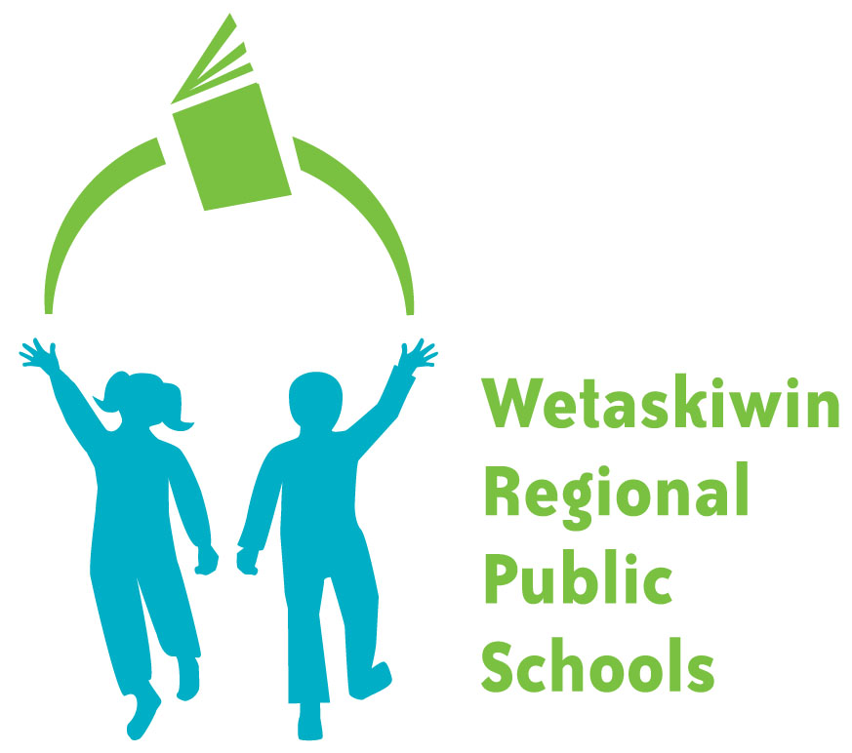
“Inspiring students to become the best they can be.”

FORM 170-1

Date: August 2017

Dear Parents:

Re: Fair Notice

The safety of our children is a top priority for us all. We, as a school system, have been involved in intensive safety training with our community partners - the police, Mental Health and Child and Family Authority. Together we have developed a plan for responding to all situations in which students may be posing a threat to themselves or others.

This letter is to inform you that we, as a school system, now have a policy that requires principals to complete a “risk assessment” in all cases of students making significant threats to harm themselves or others. The purpose of the assessment is to determine the level of risk the student poses, and how best to support high-risk students so that their behavior does not become hurtful or destructive. In all cases where staff know that a student has behaved in a threatening way please be assured that your principal will be taking measures to deal with the situation in a positive and proactive manner. If your principal invites you to a meeting to discuss safety concerns about your own child, please understand that policy is being followed and that the goal is safety, not punishment.

This letter is intended to serve our community with fair notice that we, as a school community, will not accept “no response” to a serious threat or high-risk behavior. Our goal is to respond to all high-risk situations in a professional manner that provides for a healthy and caring learning environment.

We are proud to be able to provide this level of support to our school communities and are most fortunate to have our community partners at our side.

Sincerely,
